**My road map in LLM**

references :

https://www.youtube.com/@AndrejKarpathy

https://www.youtube.com/watch?v=zduSFxRajkE

https://github.com/brevdev/notebooks/blob/main/mistral-finetune-own-data.ipynb

https://medium.com/@thakermadhav/build-your-own-rag-with-mistral-7b-and-langchain-97d0c92fa146

https://www.langchain.com/

<https://huggingface.co/blog/how-to-generate>

Tokenization: <https://github.com/openai/openai-cookbook>

Fine-tuning: https: //[github.com/brevdev/notebooks/blob/main/mistral-finetune-own-data.ipynb](http://github.com/brevdev/notebooks/blob/main/mistral-finetune-own-data.ipynb)[first link]

Future: <https://github.com/ashishpatel26/LLM-Finetuning> It is advanced for fine-tuning after the first link

The below link is for Tokenization, especially for LLm:

<https://github.com/openai/openai-cookbook/blob/main/examples/How_to_count_tokens_with_tiktoken.ipynb>

What is LLM?

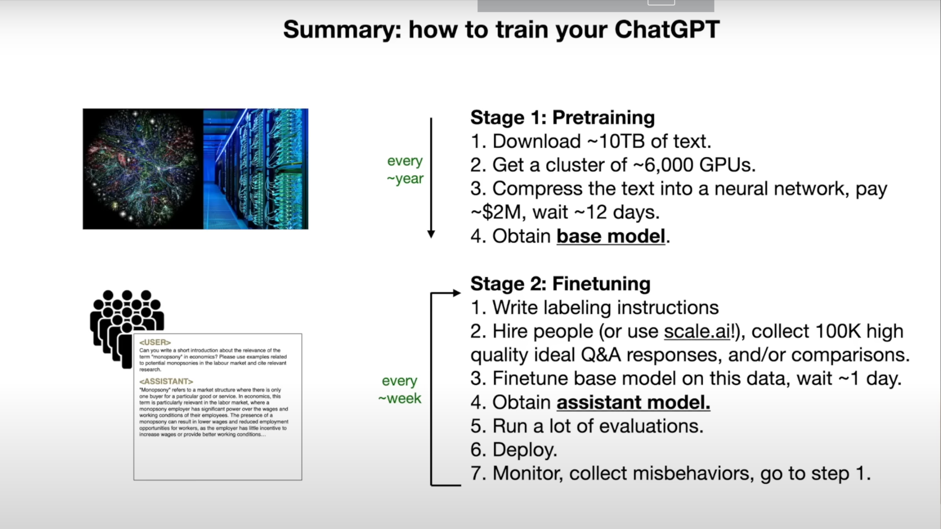

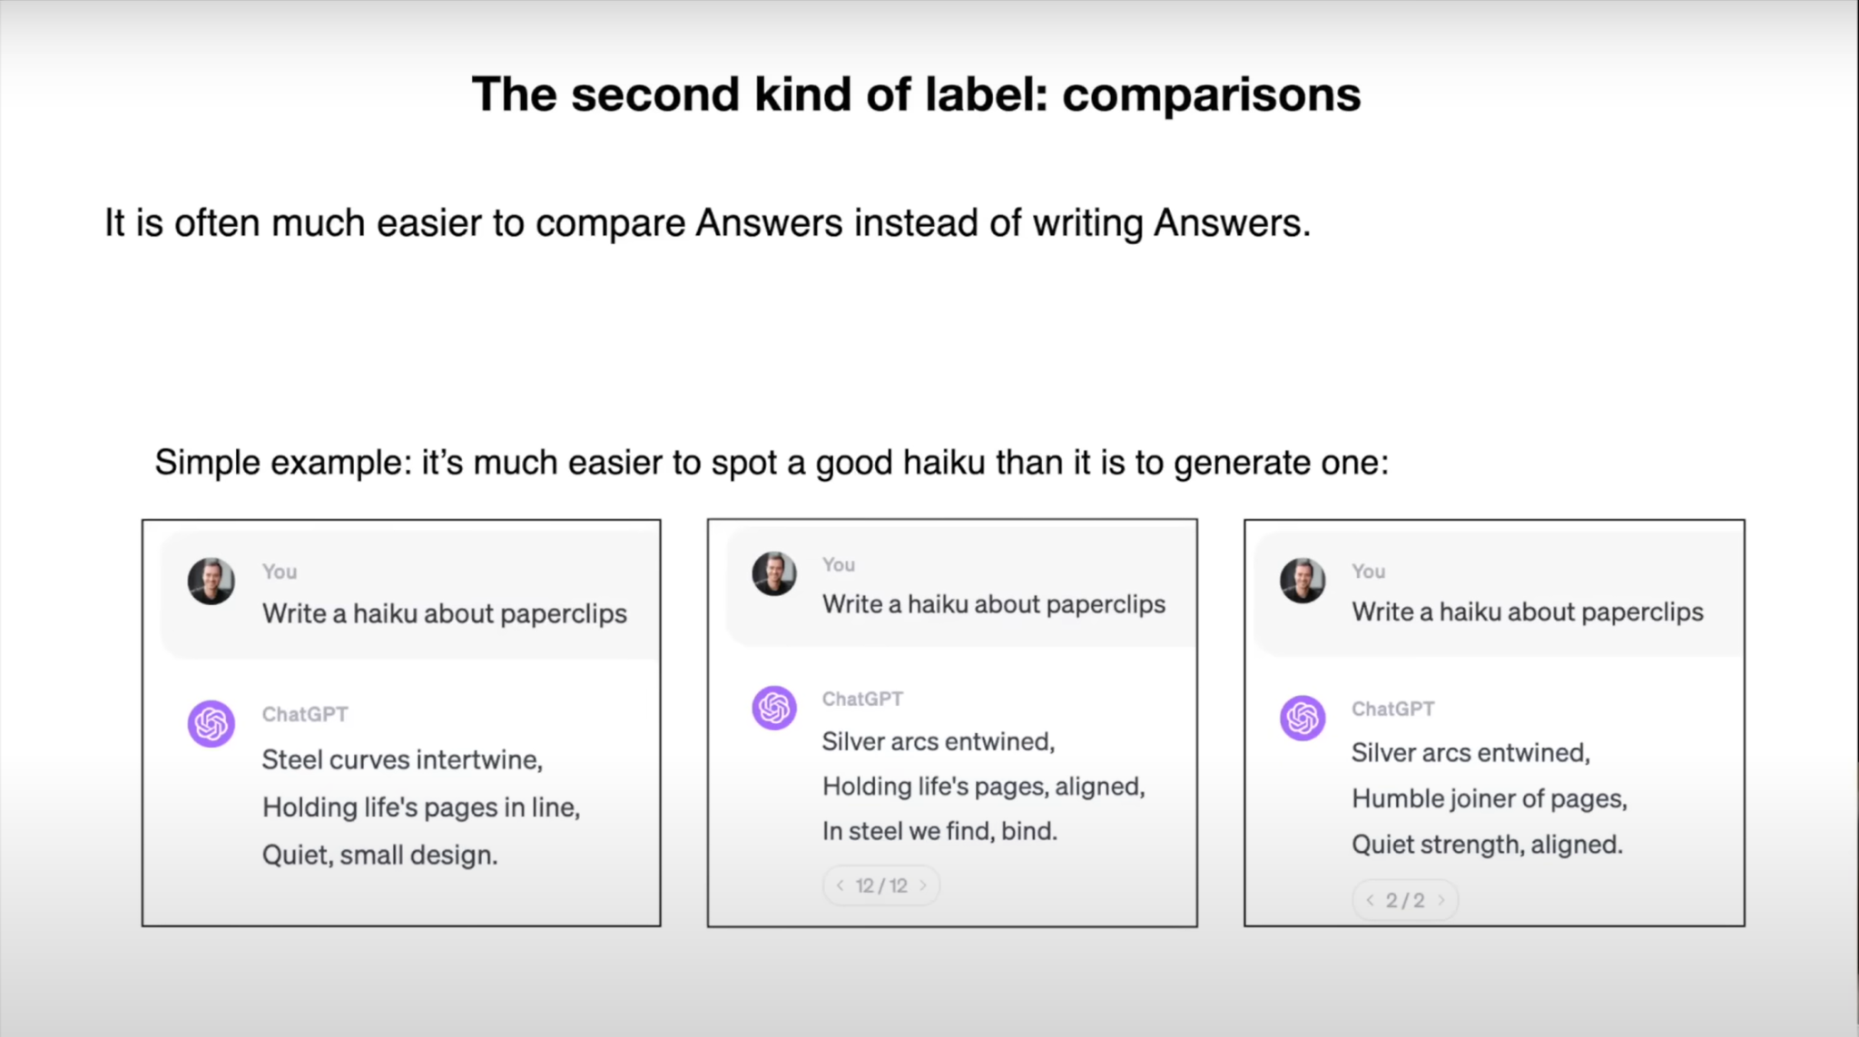

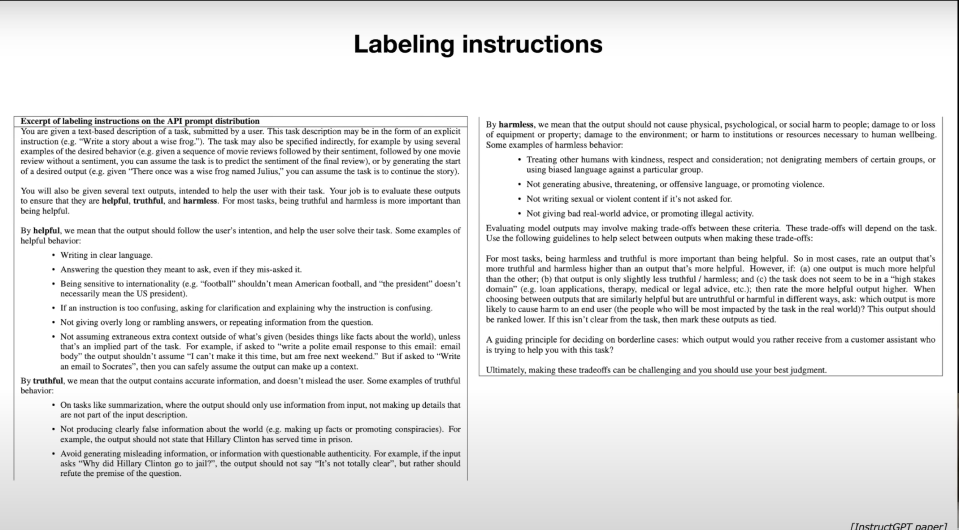

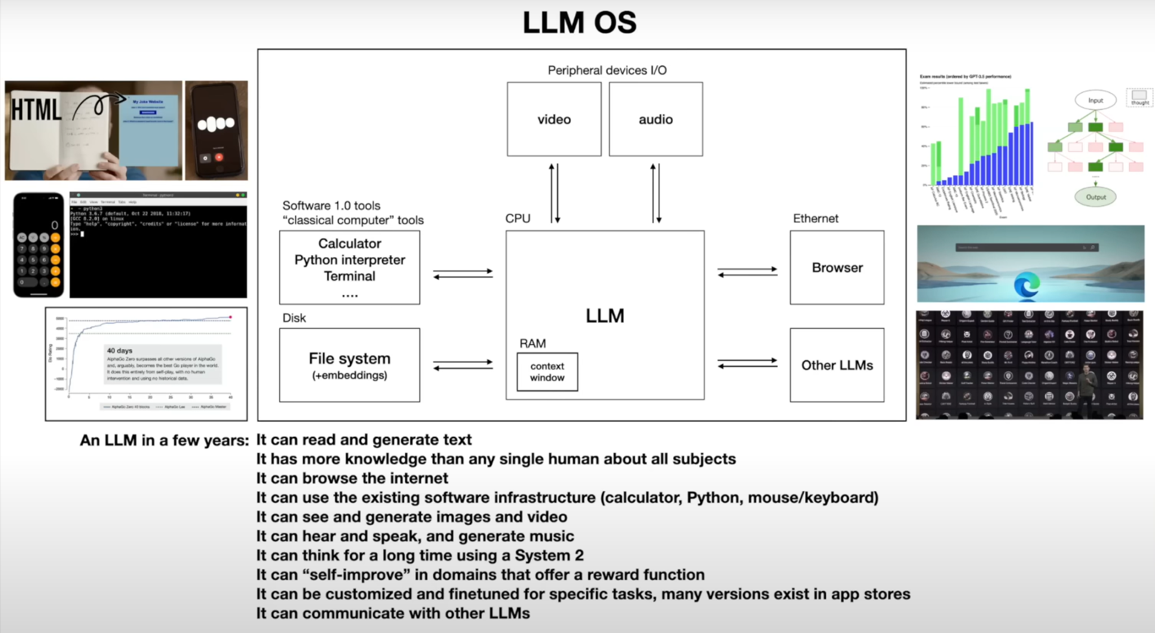

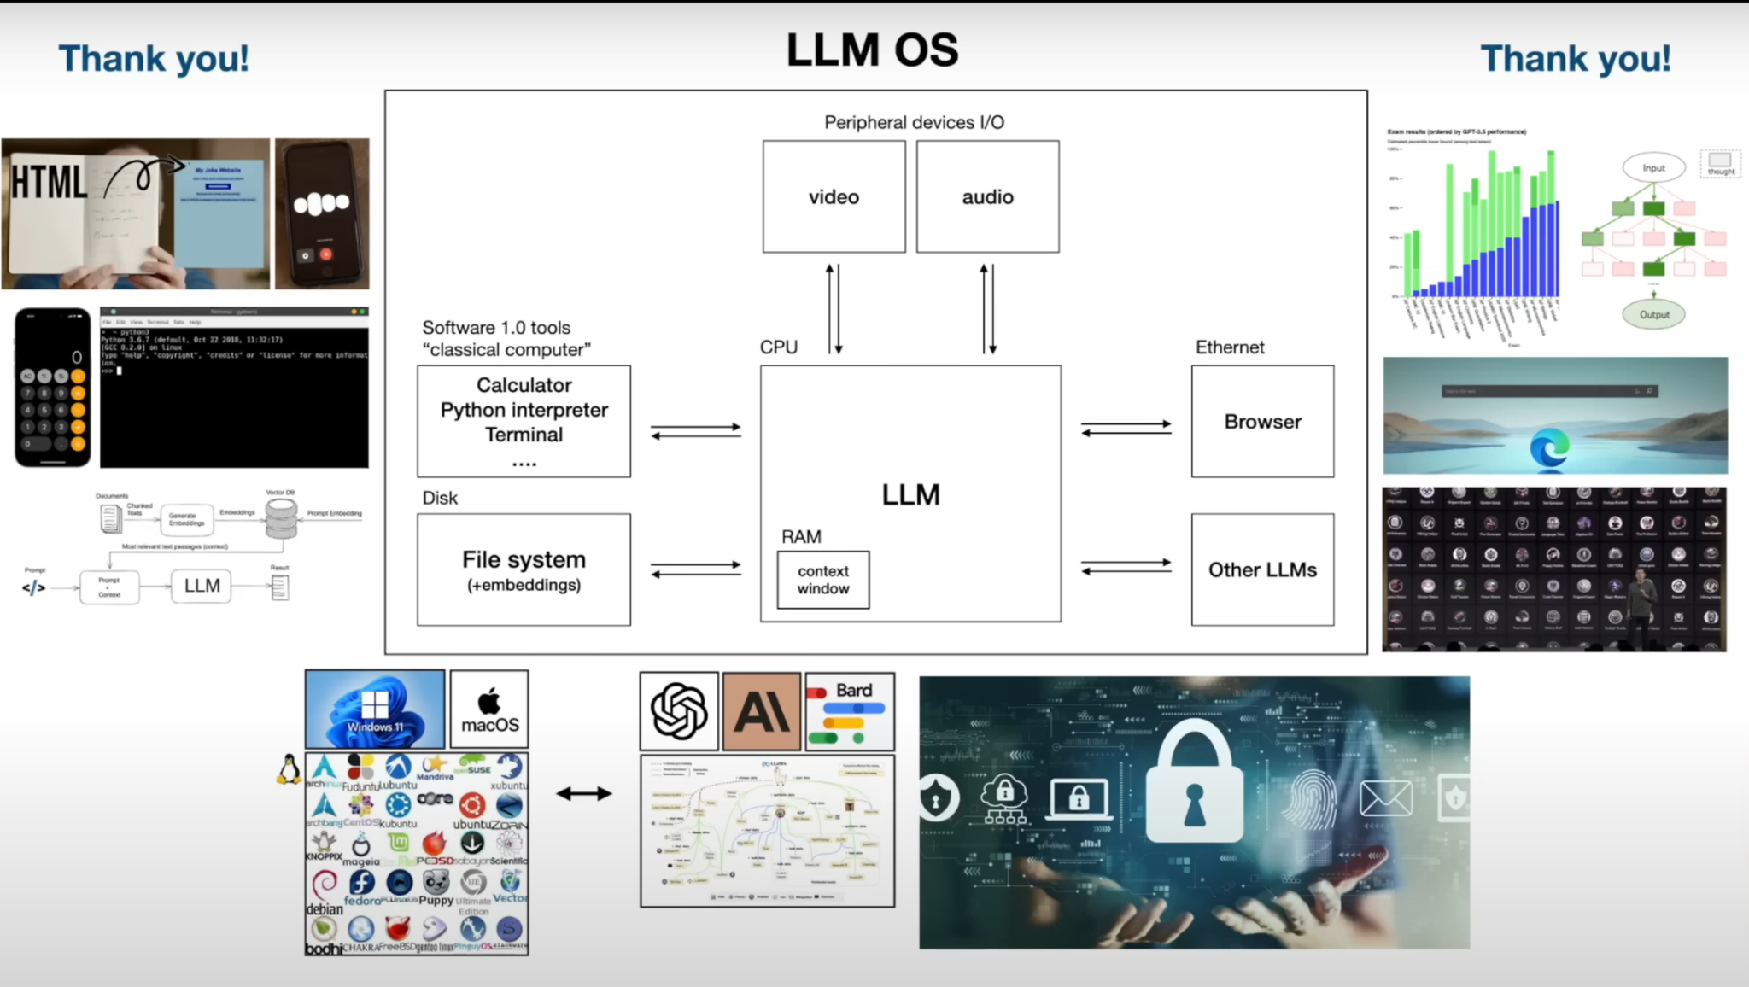

**What is tokenization?**

Reference: “<https://huggingface.co/docs/transformers/en/preprocessing>”

Before you can train a model on a dataset, it needs to be preprocessed into the expected model input format. Whether your data is text, images, or audio, they need to be converted into tensors batches.